Fun with Fossils (Grade 2)

Tennessee State Standards Covered
GLE 0207.Inq.1 Observe the world of familiar objects using the senses and tools
GLE 0207.Inq.2 Ask questions, make logical predictions, plan investigations, and represent data
GLE 0207.Inq.3 Explain the data from an investigation
0207.Inq.1 Use senses and simple tools to make observations
0207.Inq.2 Communicate interest in simple phenomena and plan for simple investigations
0.207.Inq.3 Communicate understanding of simple data using age-appropriate vocabulary
0.207.Inq.4 Collect, discuss, and communicate findings from a variety of investigations
GLE 0207.5.2 Draw conclusions from fossils about organisms that lived in the past
0207.5.3 Observe fossils or pictures of fossils and make inferences about the organisms from which they originated
0207.5.4 Compare pictures of fossils with animals or plants that are living today

Standards Connection
Geologic processes create fossils. Fossils can teach us about what life was life a long time ago.

Abstract
What are fossils, and how are they made? Who studies fossils, and what can we learn from them? We will explore the geologic processes of fossil formation, and will make some fossils of our own. Next, we will talk about paleontologists – scientists who study fossils. Finally, we will become paleontologists ourselves as we look at some real fossils and try to uncover clues about the past.

Vocabulary/Definitions
- Fossil: Something left behind by an animal or plant that lived a long time ago
- Paleontologist: A scientist who studies fossil animals or plants that lived a long time ago
- Excavation: The place where paleontologists dig for fossils
- Extinct: When a type of animal or plant that was alive once is no longer on earth

Materials
- Crayola Model Magic Fusion
- Shells, leaves, pinecones
- Fossils (horse molars, petrified wood, tree fern, shark teeth, shells, T. rex claw, saber tooth cat skull)
- A piece of wood to compare to the fossilized wood
- Photos from excavation
- Pictures of T. rex and saber tooth cat

Classroom set up
Students should be gathered in a circle, if possible. Later in the lesson they will go back to their desks for an activity, and we will regroup again at the end.

Procedure
Topic engagement: What is a fossil?
- How many people have heard of a fossil? Who can name an example of a fossil?
- If no answer, ask: How many people have been to a museum and seen a dinosaur bone? – Dinosaur bones are examples of fossils.

- Let’s brainstorm abut fossils (writing on chalkboard): Who can tell me what a fossil is? – write ideas on the board. A fossil is something left behind by an animal or plant that lived a long time ago.

Learning experiences
Where do fossils come from?
- First let’s talk about how fossils are made. Fossils form in two ways. Here’s how the first way works: an animal or plant has to live in a place where the ground is soft and muddy – usually close to water. When the animal or plant dies, sometimes it gets buried really quickly by dirt and sand. Then, over millions of years, the animal or plant turns into rock. One example of a fossil like this is this horse tooth (hold up for students to see, then pass around). Another example is this piece of petrified wood. I also have a real piece of wood, so you can see how this one has turned into rock. Notice how much heavier the fossilized wood is (pass around).
- Now, let’s talk about the other way a fossil is made. Again, usually this happens somewhere pretty wet. When an animal or plant leaves an imprint, sometimes the shape is preserved. Sometimes this type of fossil could be a footprint, or it could be an imprint of a part of an animal or plant. This tree fern is an example of this second kind of fossil (pass around). We’re going to make some imprint fossils of our own.

ACTIVITY
Students should be in groups of 4-6, preferably at their desks. A tub of Model Magic will be passed out to each group; students should divide the Model Magic so that each person has some. Paper bags with leaves and shells will be passed out too.

Demonstrate how students can generate their own fossil imprints by utilizing the fossils in the bag and pressing them into the Model Magic. Once they are able to generate a few, if time allows – let them walk around and see other student’s fossils.

Once activity is complete, have the students clean up and regroup in a circle.

Applications and Wrap-up
Who studies fossils, and what can we learn from them?
Did you know that there are some scientists called paleontologists who study fossils? The job of a paleontologist is mostly to dig in the dirt! The place where paleontologists go to dig is called an excavation. When a paleontologist is on an excavation and finds a fossil, they very carefully remove it from the dirt, and take it to a museum or lab to study it. I have some pictures of an excavation so you can see what it is like to be a paleontologist (pass around images). How many of you think you would like to be a paleontologist on an excavation?

Now, we’re going to pretend that we’re all paleontologists, and that we’re on an excavation on top of a mountain. Let’s see what fossils we find, and think about what we can learn from them (pull shark teeth, fish, and shells out of a paper bag). Here are some fossils that we just found (pass around so students can look at them). If these were living animals, where would we find them today? ( in the ocean, or at the beach) But wait a second! We’re on top of a mountain here! There are no oceans on top of the mountain! What does this mean about the environments millions of years ago? ( this is a hard question – it means that this mountain used to be covered by the ocean)

Now, let’s pretend we’re on a different excavation, maybe on the playground outside your school. We’re digging, and we find this T. rex claw (pull out of paper bag and pass around). A T. rex was a kind of dinosaur (hold up image). Well, that’s weird, because have you ever seen a dinosaur at your school? (no) Do we have any dinosaurs still alive today? (no) This fossil is telling us that this dinosaur, T. rex used to be alive, but since we don’t have any left, we know T. rex is extinct. When an animal or plant is extinct, it means it doesn’t exist any more. Here’s another example. This is the skull of a saber tooth cat (pull out of paper bag and pass around. Hold up a picture of a saber tooth cat). We don’t have saber tooth cats anymore, so this is another extinct animal. So, fossils can tell us about animals that are extinct. That’s pretty cool!

Summary
Let’s review what we learned today. Fossils are the remains of animals and plants that lived a long time ago. Fossils are made in two ways: either an animal or plant is buried and turned into rock, or the imprint of an animal or plant can be preserved. Paleontologists go on excavations to find fossil, and then they study them to learn about what life on earth was like a long time ago.

Does anyone have a question about fossils, or about being a paleontologist?
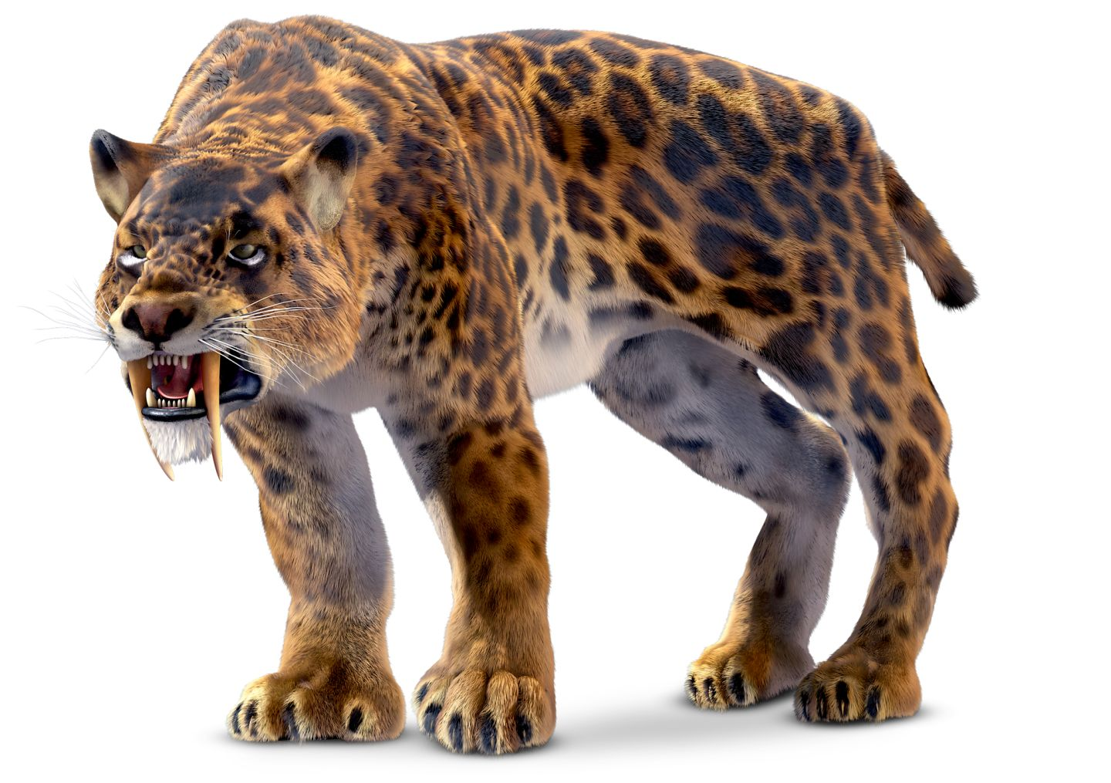

Image of Smilodon, an extinct saber tooth cat (taken fhrom dkfindout.com)

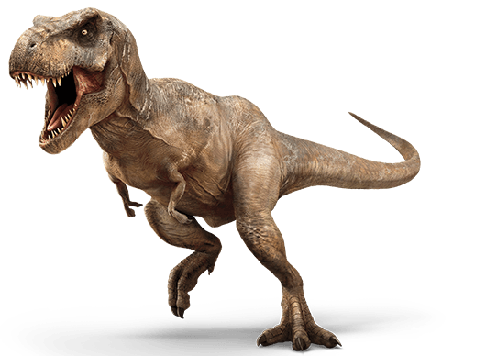
Image of T. rex, an extinct dinosaur (taken from http://jurassicpark.wikia.com/wiki/Tyrannosaurus_rex)

